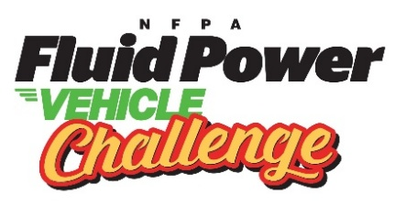
FPVC at IFP Motion Solutions | AGENDA
Event Dates: April 15 – April 17, 2026
Location: 1610 Blairs Ferry Rd NE, Cedar Rapids, IA 52402

WEDNESDAY
11:00 AM – 12:00 PM Vehicle Drop off IFP
11:30 AM Lunch optional for all attendees
12:00 PM – 4:00 PM All Teams – Safety Orientation and Final Vehicle Assembly IFP Lobby
5:30 PM Welcome Reception Pickle Palace
THURSDAY
7:00 AM – 7:20 AM Depart for IFP - Transport provided by IFP Hotel
7:30 AM Arrive at IFP - Welcome, Introductions & Safety Orientation IFP Cafeteria
8:00 AM Judges Meeting IFP (Upper Level)
8:30 AM – 11:45 AM Final Presentations, Design Review, & Safety Inspections IFP Cafeteria

8:30 AM – 11:45 AM Regenerative Braking Demonstration IFP NW Parking Lot
11:45 AM - 12:45 PM Lunch for all IFP Cafeteria
12:45 PM Group Photo IFP Lobby
1:00 PM – 3:30 PM Sprint Race, Efficiency Race, Endurance Race IFP NW Parking Lot

3:30 PM – 4:15 PM Depart for hotel - Transport provided by IFP
5:30 PM Networking Reception & Dinner Elmcrest Country Club
FRIDAY
7:45 AM Arrive at IFP IFP Lobby
8:00 AM – 9 AM Facility Tours / Bike Disassembly & Crating Round Robin IFP
8:15 AM – 8:45 AM Optional Judges Facility Tour IFP
9 AM – 10 AM Judges Meeting IFP (Upper-Level)
10:30 AM – 1 PM Roundtable & Award Ceremony Cedar Ridge Winery & Distillery
Schedule subject to change
Maps & Important Addresses:
- Google My Map – 2026 FPVC Cedar Rapids, IA
- IFP Motion Solutions: 1610 Blairs Ferry Rd NE, Cedar Rapids, IA 52402
- Pickle Palace: 101 1st Ave SW, Cedar Rapids, IA 52404
- Elmcrest Country Club: 1 Zach Johnson Dr N E, Cedar Rapids, IA 52402
- Cedar Ridge Winery & Distillery: 1441 Marak Road, Swisher, IA 52338

