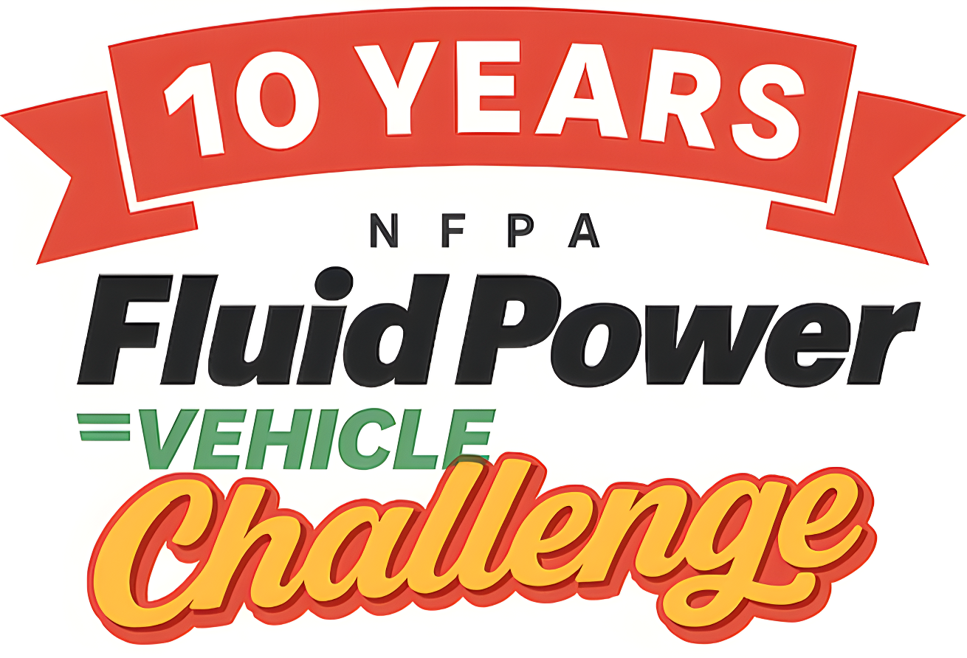

2025-26 NFPA Fluid Power Vehicle Challenge
FINAL COMPETITION – April 15-17, 2026
IFP Motion Solutions, Inc | 1610 Blairs Ferry Road NE.| Cedar Rapids, IA 52402
Final Competition Information

VP, Workforce Development Technical Liaison
Stephanie Scaccianoce Randy Nobles, VP Technology
National Fluid Power Association Evolution Motion Solutions
sscaccianoce@nfpa.com rnobles@evolutionmotion.com
(414) 778-3345 (918) 230-5092

Final Competition Event Host Industry Program Manager
Jim Kaas Erin Bauer
IFP Motion Solutions Inc. National Fluid Power Association
fpvc@ifpusa.com ebauer@nfpa.com
(414) 259-2039

Workforce Program Manager
Mary Pluta
National Fluid Power Association
mpluta@nfpa.com
(414) 736-3584
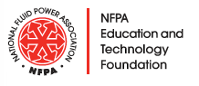

FINAL COMPETITION OVERVIEW
The NFPA Fluid Power Vehicle Challenge final competition will be hosted by IFP Motion Solutions, Inc., donor to the NFPA Foundation’s Pascal Society, from April 15-17, 2026.

“IFP is thrilled to host the 2026 NFPA Fluid Power Vehicle Challenge at our home office in Cedar Rapids, IA! We look forward to welcoming each team and seeing the ingenuity and innovation you bring to the competition. Your creative problem-solving and unique designs continue to inspire us year after year. We're excited for what promises to be an outstanding event!"
— FPVC Team at IFP

The final competition will be an exciting event where students, advisors, industry representatives, and other invited guests experience the final leg of this dynamic undergraduate engineering design challenge. Students will present and demonstrate their designs; industry representatives will judge their work, and winners will emerge.

Student teams arrive at IFP Motion Solutions, Inc. in Cedar Rapids, IA on Wednesday to complete all necessary vehicle assembly. They get to meet other participants and industry representatives at a welcome reception that night.

On Thursday, it’s back to IFP for the final presentation and design review to demonstrate the system’s integrity and readiness to operate. The competition kicks off when the action moves outside for the regenerative braking demonstration and the three races – sprint, efficiency, and endurance. Thursday night, all participants are invited to a networking reception and dinner in Cedar Rapids.

Competition events continue early Friday for a facility tour and to pack vehicles for return to universities while judges deliberate. To wrap up the event, everyone gathers for a vehicle performance roundtable and final award ceremony lunch. Teams travel home on Friday afternoon.

*Schedule subject to change due to weather conditions.
IMPORTANT DATES and DEADLINES (see additional details below)
Registration by: February 16, 2026
Hotel reservations by: March 27, 2026
Proof of working vehicle by: March 30, 2026
Vehicle Pick-Up if Shipping: April 3, 2026
Final Presentation & All Mentor Summaries by: April 13, 2026
If driving, deliver the vehicle by: April 15, 2026 at between 11 AM and 12 PM
Travel Reimbursement and Award Delegation documentation by: May 18, 2026
Click Here for a Map of Cedar Rapids Event Locations

Contents
FINAL COMPETITION OVERVIEW 1
FPVC Website 3
REGISTRATION 4
PROOF of WORKING VEHICLE & PHOTO 5
VEHICLE TRANSPORT LOGISTICS 6
Drive and Deliver 6
Shipping 6
Materials, Equipment and Supplies 8
ARRIVAL 8
Tuesday, April 14 8
Wednesday, April 15 8
Thursday, April 16 9
Friday, April 17 9
ON-SITE PARKING 9
DRESS CODE 10
SAFETY 10
EVENT RACES 11
JUDGING PROTOCOLS 11
WI-FI ACCESS 11
HUMAN RESOURCES 11
NFPA FPVC POLICIES 12
HOST SITE POLICIES 12
FINAL THOUGHTS 12

This document is intended to provide more specific details related to the final competition event. Participants should carefully review the Overview, Rules and Awards document to ensure they understand program details and procedures.

FPVC Website
For the most up to date details and documentation, refer to the Vehicle Challenge website.

SOCIAL MEDIA HASHTAG
The Vehicle Challenge hashtag is #FPVC10. Please use this on all of your social media posts about your project and the event. And don’t forget to take and share lots of photos! Show the world your vehicle, your team, and all your favorite parts of the Challenge (like your travel to Cedar Rapids, the nightly events, and the Competition). Remember to tag the NFPA and IFP on your posts (see table below) and use the hashtags

 | Instagram | LinkedIn
NFPA | @The_NFPA | @TheNFPA
IFP | @ifp_motion | @IFPUSA

REGISTRATION
All general attendees including student teams, faculty advisors, industry supporters and judges, are required to complete final competition registration by February 16. Register here. Remember to refer to the Overview, Rules and Awards document for details regarding the procedures, stipends and awards.

Advisors will be asked to:
- Indicate whether the team will be shipping or driving and delivering their competition bike to IFP.

Travel and Other Expense Reimbursement
For travel and qualifying expenses related to the final competition, NFPA will reimburse up to a total of $5,000 directly to universities for one faculty advisor and up to seven students participating in the event.
- Advisors or university faculty will be required to submit the NEW Travel Reimbursement and Award Form in excel format and one PDF file of all receipts and supporting documents to Erin Bauer at ebauer@nfpa.com no later than May 18th.
- NFPA will reimburse based on submitted receipts only and reserves the right to deny reimbursement if expenses are unrelated to the final competition or not a qualified expense.
- Travel reimbursements will be paid to the university, not individuals. There will be no exception to this rule.
- Itemized receipts are required for every expense item. There will be no exception to this rule.

If travel creates a personal or institutional financial hardship, please inform Erin ASAP.

Team Accommodations
Student teams and advisors are to make hotel reservations following these instructions:
Hampton Inn & Suites – Cedar Rapids
1130 Park Pl NE, Cedar Rapids, IA 52402
Check In: 3:00pm
Check Out: 12:00pm
Rate: $105.00 + tax
Complimentary Breakfast
Front desk: 1-319-832-1130
Booking Link
Cut-off Date: March 27, 2026

(If you do not book your room by this date, you will not get the reduced rate of $105.00).
Reservations can be made via link or direct phone call. Mention the dates of your stay and the group name of “National Fluid Power Association” to receive the group rate. If you need to book a room for Monday night, please call the hotel directly. Please be sure to book your lodging as soon as you can. If needed, room cancellations can be made up until 24 hours prior to arrival.

Qualifying Reimbursable Expenses:
- Team Accommodations at the hotel that NFPA designates.
- Team Transportation
  - Airfare (coach/ economy flights only)
  - Auto rental
  - Trailer rental
  - Personal vehicle mileage
- Travel Related Expenses
  - Meals not provided by NFPA or Vehicle Challenge event host.
  - Taxi, Uber, Lyft, Tollways, Parking, etc.
  - Other qualifying expenses as determined by NFPA.
Please see the Overview, Rules and Awards Document for more information.

PROOF of WORKING VEHICLE & PHOTO
It is required that teams demonstrate your vehicle is in working condition by submitting a YouTube video to the website indicating your intent to participate in the final event. The footage must:
- Confirm that the vehicle is safe and operational with a team member riding it at least ½ a block or better.
- Verify stored energy working off the accumulator.
- Confirm the use of pressure indicators and test point.
- Your proof of a working vehicle must be received by March 30. Teams can manage who can view content through privacy settings of YouTube videos. Learn how here. Teams are also required to submit one photo of only their vehicle for judges to refer to during the final competition. Submit your video here!

VEHICLE TRANSPORT LOGISTICS
There are two options for transport and delivery of the vehicles. 1) Drive and deliver to the competition location, or 2) Ship. Vehicles should be crated no matter which delivery method is chosen, although not required for drive and delivery if properly secured in a trailer. Be sure the crate is forklift compatible. Teams may build a crate from scratch or use a crate from a previous year. Crates must be sturdy and able to withstand rough handling. Vehicles and any other items must be secured inside of the crate. Here is an example of a well-made crate from last year’s competition. If shipping, release all oil pressure and lower the nitrogen pressure to 50 PSI. Do not empty the accumulator all the way and let air into it. Keep 50 PSI in the accumulator (plus or minus 25 PSI is okay but aim for 50 PSI). If not shipping, you may keep your accumulator charged.

Drive and Deliver
If you choose to drive and deliver your vehicle to IFP, be sure it is secure in every possible way during transport and delivery. The vehicle drop off window is Wednesday, April 15, 11-12:00 PM.
Deliver to doors E1, E2, or E3. (These doors are all located at the same spot on the building, with
different unloading options available.) After unloading, enter through door D (Customer Service Door) and ask for Tony Brayton. If needed, you may also contact Tony directly, 319-739-6367.
If driving, teams must bring fluid from AMSOIL to IFP.

Shipping
SHIPPING via eShipping
NFPA will cover the cost of shipping your vehicle through eShipping. If you choose to ship, each university will be responsible for arranging shipping via pickups.eshipping.biz. Competition bikes will be picked up 10 days before the Welcome Ceremony. Arrange for shipping at least two weeks before the start of the competition. April 3rd will be the pick-up day for teams that choose to ship their competition bikes.
- Crates should not exceed 6 feet in length.
- Each team will be required to print the Bill of Lading to accompany their crate.
- The crate must be forklift compatible.
- Fluids from AMSOIL and nitrogen will be provided on-site.
- Teams do not need to ship fluid or nitrogen.
- NFPA will not pay for expedited shipping.
- If shipping, teams do not need to ship fluid or nitrogen.

Note: If the bike needs to be shipped back to your university by a certain date, the university will be responsible for this expense, and it will not be reimbursed. If you need to make these arrangements, contact Erin at ebauer@nfpa.com.

PROCESS: OUTBOUND FROM THE UNIVERSITY
Teams that ship vehicles will need to schedule their pickup online via pickups.eShipping.biz. You will be filling out an online form. Here is the information you need:
- Shipper: Full school address where the crate will be picked up and primary contact for the pickup.
- Who is paying for this shipment? Enter “NFPA”.
- Recipient: IFP Motion Solutions (ATTN: Tony Brayton)
- 1610 Blairs Ferry Rd NE, Cedar Rapids, IA 52402
- The pickup window will be 1-5 pm in your time zone.
f. Freight Item
- Freight Type: Crate
- Quantity 1
- Team to provide the estimated weight of the vehicle/supplies including the crate, as well as the length, width, and height of the crate.
- Is the freight stackable? Select “No”
- Product Details
- Is the product Hazmat? Select “No”.
- Package Type: crate
- Freight Class: 250
- Quantity: 1
a.NMFC: 189800
- Product Description – Bicycles, NOI
- Is the product new? Select “New”.
- Insurance
- Does this shipment require insurance?
- Select “Decline Insurance”.
- Other Instructions
- Does this shipment need a guaranteed delivery date? Select “No”.
- We do not need a guaranteed delivery date if you ship by April 3rd, 2026
- Reference Details:
- PO Number Required for Pick up? Enter “NFPA”
- Reference number required for pick up? Select “No”.
- Notes and Instructions: N/A
- Accessorials
- Only select “Limited Access Pickup”.

PROCESS: OUTBOUND FROM COMPETITION
Follow the same steps listed above to arrange return shipping. The shipper is IFP, and the recipient is your university. Schedule your vehicle to be picked up the Monday after the competition. Send a PDF of your return Bill of Lading to Erin by Monday, April 13th at 11 AM CDT.

Materials, Equipment and Supplies
You must bring your own tools, equipment, and supplies. Nitrogen and hydraulic fluid from AMSOIL will be provided on-site. Depending on how you travel, decide the best method of transporting tools, equipment, and supplies. Packing tools in the vehicle crate is a commonly used option, provided that all additional materials are properly secured. Bring all needed items to IFP as participants will not be allowed to leave the facility to collect supplies left behind.

ARRIVAL

Tuesday, April 14
Tuesday is considered a travel day as needed and will qualify as a reimbursable expense. Please see the details for hotel accommodations above.

Wednesday, April 15
Teams are required to arrive at the host site at noon to drop off vehicles, open crates and set up their assigned bay area, and conduct any final vehicle assembly. Industry representatives are encouraged to join and support final vehicle assembly and meet teams.
11am – 12 pm – Vehicle Drop-off
11:30 am – Lunch optional for all attendees
12 pm – All teams required for vehicle check in and assembly, Industry/Judges optional
4 pm – All attendees depart from IFP.
5:30 pm – Welcome Reception for all attendees at Pickle Palace located at 101 1st Ave SW, Cedar Rapids, IA 52404.

Thursday, April 16
There will be no on-site parking at IFP on race day. Event arrival and departure transportation will be provided by IFP for all attendees on race day. All attendees are responsible for their own transportation to the Networking Dinner.

7 – 7:20 am – All Attendees depart for IFP. Transport provided.
7:30 am – All attendees arrive for Welcome, Introductions, Safety Orientation
8:00 - Judges Only – Initial Meeting
8:30 am – All attendees - Final Presentations, Regenerative Braking Demonstration and Races
4:15 pm – All attendees depart from IFP. Transport provided.
5:30 pm – Networking Dinner at Elmcrest Country Club located at 1 Zach Johnson Dr N E, Cedar Rapids, IA 52402.

Friday, April 17
All teams arrive at IFP to prepare their vehicles for transport and do a facility tour. All judges and industry representatives are invited to do a facility tour at 8:15 am. If judges do not do the tour they should arrive at IFP in time for the final judges meeting to select awards beginning at 9 am.
All attendees will meet at Cedar Ridge Winery & Distillery located at 1441 Marak Road, Swisher, IA 52338 for the Roundtable on Vehicle Performance and Award Ceremony. The roundtable discussion is not a scored element of the competition, but rather, it is an opportunity to talk freely with judges and other teams about vehicle performance. All attendees are responsible for their own transportation to the Award Ceremony.
7:45 am – All teams depart for IFP for facility tour and vehicle transport prep.
8 am – 10 am – team tours/vehicle transport prep (Round Robin)
8:15 am – Optional facility tour for Judges/Industry Representatives
9 am – Final Judges Meeting
10:30 am – Roundtable on Vehicle Performance
11 am – Award Ceremony Lunch - Cedar Ridge Winery & Distillery
1 pm – Event ends

ON-SITE PARKING
Parking is available at IFP on Wednesday and Friday only. There will be no on-site parking at IFP on race day. Event arrival and departure transportation will be provided by IFP on race day.

DRESS CODE
The dress code for non-competition events is business casual. Explicitly, the dress code is less formal than traditional business wear, but it is intended to give a professional and business-like impression. The dress code for competition events is informal and casual; however, steel toe shoes are required. No shorts or skirts are allowed for safety reasons. Remember, there will be long periods of time when teams are outside, dress accordingly and plan for the weather. Students are encouraged to wear university-branded shirts to identify different teams on the track.

SAFETY
During the competition events and facility tours, personal protective equipment is required:
- Footwear: Participants are to wear reasonable footwear for the event and factory tour. No open-toed shoes, sandals, heels, or thick-soled shoes. Steel toe shoes are required. Please bring your own steel toe shoes. NFPA stipend funds can be used to purchase these if you do not own them.
- Eyewear: Safety glasses with side shields are required. Bring your own or safety glasses will be provided.
- Riders must bring and securely fasten a CPSC-approved bike or motorcycle helmet during the competition events. See photos below.
- Attire to avoid: shorts, loose-fitting clothing, loose necklaces/bracelets.
- Long hair must be tied back during the facility tour.

Note: CPSC Approved Helmets have this sticker. Photo Credit: Beactivedecatur.com
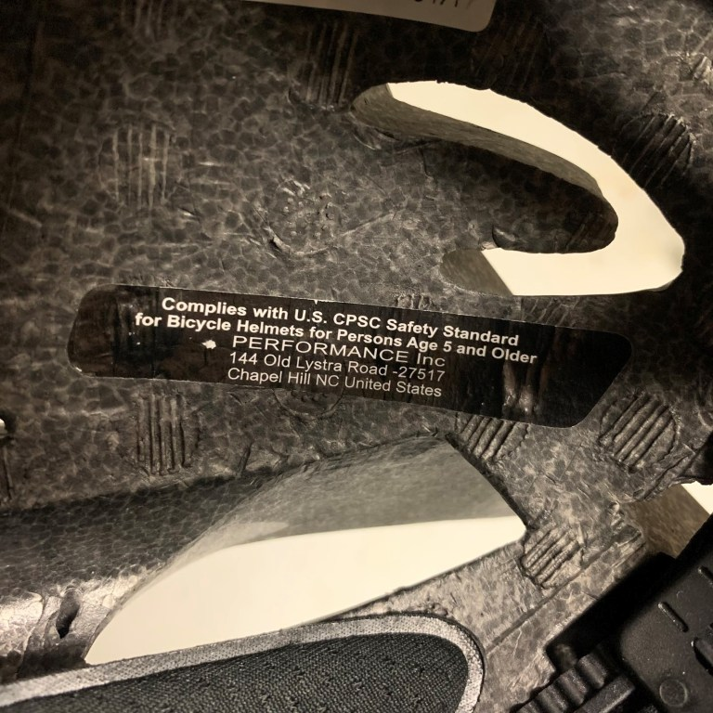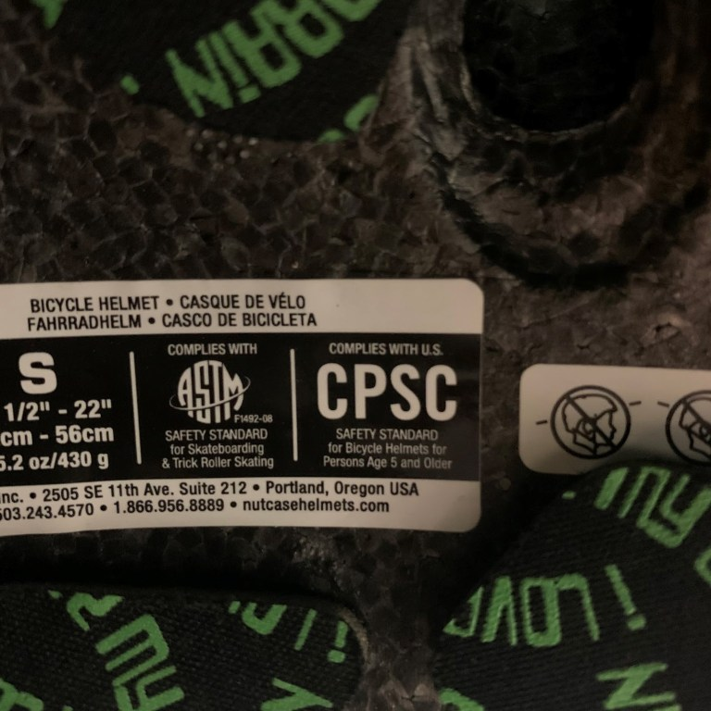

FINAL PRESENTATION AND MENTOR SUMMARIES
Teams will submit their final presentations and mentor summaries on the Vehicle challenge website no later than April 13th at 11 AM CDT. Consider this to be the final submission. Teams will not be able to modify or resubmit their presentation after the deadline.

EVENT RACES
The event races will demonstrate the various elements of the vehicle design. The straight track for the sprint race is 300 ft long. The track loop for the Efficiency and Endurance Challenge races is between 400-450 ft. Here is a Track Map for your information.

JUDGING PROTOCOLS
The final competition relies on the volunteer commitment of industry representatives.

Judging Committee

A team of industry judges is responsible for assessing the vehicle on-site. All judges are responsible for ensuring teams operate in a safe and sportsmanlike way during the entire event, and may be responsible for recording time, submitting data for scoring reports, and evaluating presentations. Judges will be divided into two teams.

Regenerative Braking Demonstration Judges
This group of judges will test the regenerative braking circuits of the vehicles. The course will require at least one stop to go into regenerative mode to recover energy and use only regenerative energy to restart and propel the vehicle for at least 10 feet.

Assigned Judges
This group of judges will be responsible for evaluating the final presentations and design review for each team, monitoring accumulator charging, and recording race results for submission to NFPA staff.

Judges may walk, jog, run, or cycle alongside the vehicle during a competition event. Judges will provide input to the judging committee on the vehicle performance and teamwork of the event participants.

AWARDS
The Judging Committee determines final award winners based on a number of factors, including the overall assessment of (1) the Midway Review and Final Presentation, (2) the competition results, (3) Interaction with Industry Mentors. The decisions of the judging panel are final.

WI-FI ACCESS
Network: IFPEHA-FPVC Password: FPVC2026!

HUMAN RESOURCES
Talent scouts and industry representatives will be available during lunches and dinners as an opportunity for students to network with fellow engineers and ask questions in an informal setting. Please bring a printed copy of your resume if you are still looking for a job.

NFPA FPVC POLICIES
During the final event, any participant demonstrating unsportsmanlike or unsafe conduct will be disqualified from the Challenge and forfeit any and all awards. Driving under the influence is automatic elimination. Same rules apply as driving a motor vehicle on the highway. It is expected that all participants will honor the Host Site’s local zero-tolerance policies. Avoid touring the facility in search of restrooms. Restrooms that are to be used by Fluid Power Vehicle Challenge participants will be clearly marked with signage. No guests are permitted at the competition.

HOST SITE POLICIES
All attendees will be required to attend a welcome session and safety orientation, prepared by the event host. IFP has a zero-tolerance weapon, alcohol, and tobacco-free campus policy. Ecigarettes and vaping devices are also prohibited. Participants are subject to elimination and being removed from campus for violating these stated policies.

FINAL THOUGHTS
Let’s make a great impression on IFP and the other industry representatives that support this program. Both personally, and professionally, you can never have too many friends.

