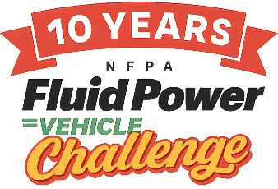
FPVC at IMI | AGENDA
Event Dates: April 22-24, 2026
WEDNESDAY
11 AM – 12 PM Vehicle drop off and optional lunch IMI
12 PM – 4 PM Complete vehicle assembly and pre-race inspection
5:30 PM Welcome Reception Rockford Country Club

THURSDAY
7:30 AM Arrive at IMI, Welcome, Introductions and Safety Presentation IMI
8 AM Judges Meeting
8:30 AM – 11:45 AM Final Presentations & Design Review, Safety Inspection, Regenerative Braking Demonstration
11:45 AM - 12:45 PM Lunch
12:45 PM Group Photo
1 PM – 4 PM Sprint Race, Efficiency Race, Endurance Race, Regenerative Braking Demonstration
6 PM Networking Reception & Dinner Nicholas Conservatory

FRIDAY
7:45 AM Arrive at IMI IMI
8 AM – 10 AM Facility Tour/ Vehicles disassembled, crated, ready to transport
9 AM – 10 AM Judges Meeting (Large Conference Room)
10:30 AM – 1 PM Roundtable on Vehicle Performance, Award Ceremony and Lunch Hilton Garden Inn
Schedule subject to change
Important Addresses:
IMI: 10914 N. 2nd St., Machesney Park, IL 61115
Rockford Country Club: 2500 Oxford St., Rockford, IL 61103
Nicholas Conservatory and Gardens: 1354 N. 2nd St., Rockford, IL 61107
Hilton Garden Inn: 7675 Walton St., Rockford, IL 61108

